Project Design Phase-II
Technology Stack (Architecture & Stack)

Date | 18 February 2026
Team ID | LTVIP2026TMIDS65799
Project Name | Online Payments Fraud Detection using Machine Learning
Maximum Marks | 4 Marks

Technical Architecture:
The Deliverable shall include the architectural diagram as below and the information as per the table1 & table 2
Example: Order processing during pandemics for offline mode
Reference: https://developer.ibm.com/patterns/ai-powered-backend-system-for-order-processing-during-pandemics/
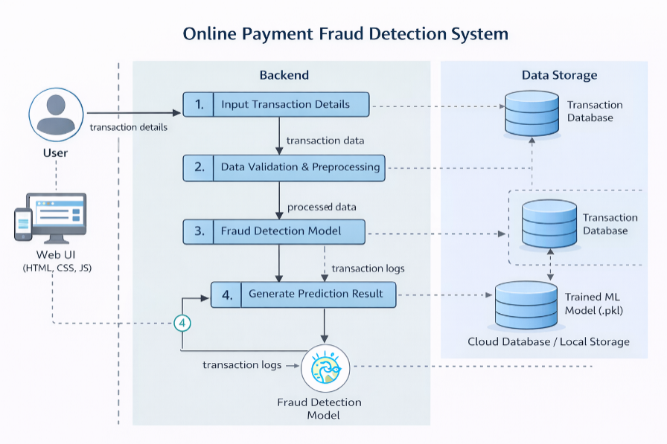
Guidelines:
Include all the processes (As an application logic / Technology Block)
Provide infrastructural demarcation (Local / Cloud)
Indicate external interfaces (third party API’s etc.)
Indicate Data Storage components / services
Indicate interface to machine learning models (if applicable)

Table-1 : Components & Technologies:
S.No | Component | Description | Technology
 | User Interface | Web interface for entering transaction details and viewing prediction results | HTML, CSS, JavaScript
 | Application Logic-1 | Input validation and request handling logic | Python (Flask / FastAPI)
 | Application Logic-2 | Data preprocessing and feature engineering | Pandas, NumPy
 | Application Logic-3 | Fraud detection inference logic | Scikit-learn
 | Database | Stores transaction logs and prediction results | SQLite / MySQL
 | Cloud Database | Database service hosted on cloud | Render Cloud DB / Managed MySQL
 | File Storage | Storage of trained ML model file (.pkl) | Local File System (Server Storage)
 | External API-1 | (Future Enhancement) Payment Gateway Integration | Razorpay / Stripe API
 | External API-2 | (Future Enhancement) SMS/Email Alert Service | SMTP
 | Machine Learning Model | Fraud classification model for predicting fraudulent transactions | XGBoost
 | Infrastructure (Server / Cloud) | Application deployment and hosting environment | Render Cloud Platform

Table-2: Application Characteristics:
S.No | Characteristics | Description | Technology
 | Open-Source Frameworks | Backend and ML libraries used in development | Python, Flask, Scikit-learn
 | Security Implementations | Secure data transmission, input validation, and encrypted communication | HTTPS, SSL, Form Validation
 | Scalable Architecture | Three-tier cloud-based architecture supporting scaling | Cloud Deployment
 | Availability | Cloud hosting ensures high uptime and accessibility | Render Cloud
 | Performance | Fast ML inference with optimized model loading | Pre-trained ML Model

References:
https://c4model.com/
https://developer.ibm.com/patterns/online-order-processing-system-during-pandemic/
https://www.ibm.com/cloud/architecture
https://aws.amazon.com/architecture
https://medium.com/the-internal-startup/how-to-draw-useful-technical-architecture-diagrams-2d20c9fda90d

